TASK9

**DYNAMIC LOGO CHANGE WITH PAGE NUMBER SEPERATION FOR SUPPLIERS**

(PURCHASE ORDER MODULE)

*G0->BI PUBLISHER->LOAD SAMPLE DATA.

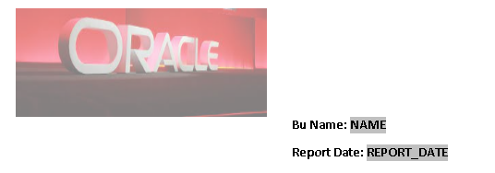

*HEADER->INSERT LOGO -> BU DETAILS(DOWN).

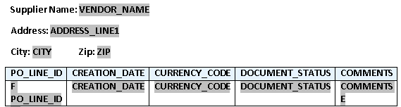

*CREATE TABLE WITH REQUIRED COLUMNS AND GIVE REPEATING GROUP FOR COLUMNS.

**LIMIT RECORDS PER PAGE**

*CLICK CLOSING REPEATING GROUP(E).



*TYPE THE CODE BEFORE <?end for-each?>.

<?if:position() mod 12 =0?> <xsl:attribute name="break-before">page</xsl:attribute> <?end if?><?end for-each?>

*GIVE LIMIT AS WE NEED RECORD IN SINGLE PAGE(HERE 12 RECORDS).

**TO DISPLAY ALL SUPPLIER DETAILS IN BU AND PAGE NUMBER SEPERATION

FOR EACH SUPPLIER**

*CREATE LEGACY TOOLS AND CODE <?for-each-group:G_1;./VENDOR_NAME?>(TO DISPLAY SUPPLIER)

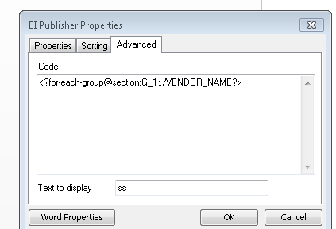

*TO SPLIT THE PAGE NUMBER ACCORDING TO SUPPLIER DEATILS ADD @SECTION INFRONTOF (:G_1).

[<?for-each-group@section:G_1;./VENDOR_NAME?>](mailto:<?for-each-group@section:G_1;./VENDOR_NAME?>)

*CREATE LEGACY TOOL TO CLOSE FOR EACH GROUP.(AS WE ALL KNOW).

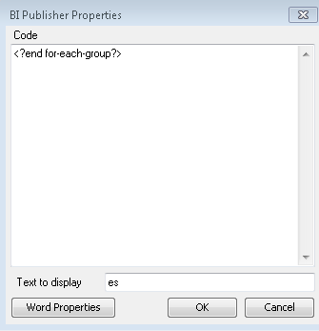

*CODE <?end for-each-group?>

**SEPERATE LOGO FOR EACH SUPPLIER**

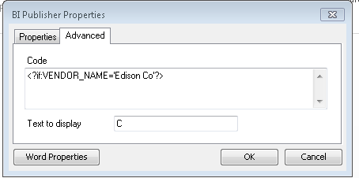

*LEGACY TOOLS -> CODE -> <?if:VENDOR_NAME='Edison Co'?> GIVE SUPPLIER NAME RELATED TO OUR BU.(JUST IF CONDITION).

*AFTER THAT PLACE THE SUPPLIER LOGO.

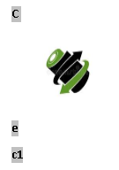

*CLOSE IF CONDITION -> LEGACY -> <?end if?>

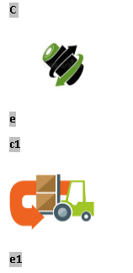

*SIMILARLY DO AS MANY SUPPLIER LOGO WE HAVE IN OUR BU.

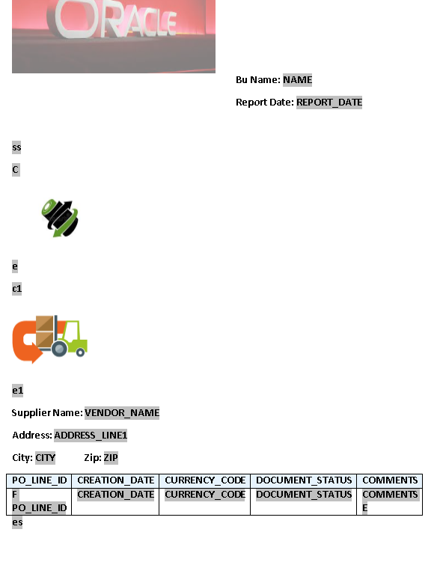

*THE ABOVE IS THE WHOLE LAYOUT SNAP.ss(for each group(vendor)).es(closing of for each group).

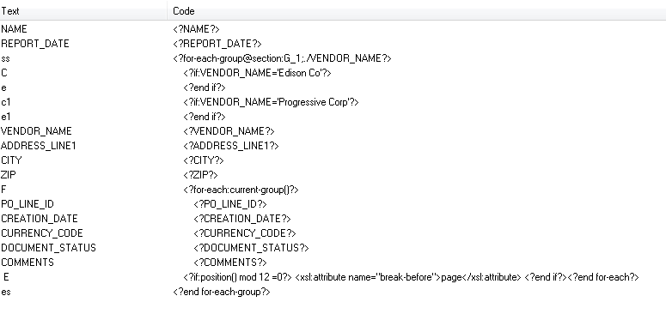

*ABOVE IS THE WHOLE CODE FOR DYNAMIC LOGO,PAGE NUMBER SEPERATION AND RECORD LIMIT PER PAGE.